**Design Document**

1. **Goal**

**2. User Experience**

2.1 Audience Definition

2.2 Scenarios

2.3 Competitive Analysis Summary

**3. Site Content**

3.1 Content Grouping and Labeling

**4. Site Structure**

4.1 Metaphors (or summary)

4.2 Site Structure

4.3 Global and Local Navigation Systems

Task bar at the top of page

Drop down menu

**5. Visual Design**

5.1 Layout Grids

5.2 Mood Boards

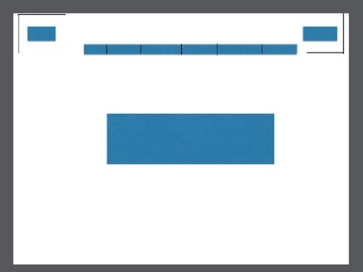

5.3 Page Mock-ups

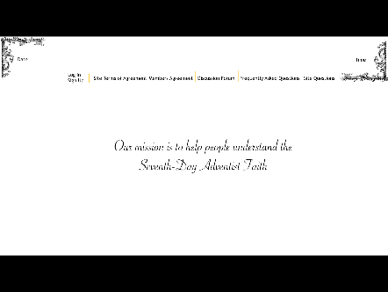

**Appendix A:** Competitive Analysis

**Appendix B:** Content Inventory

**Appendix C:** Site Structure Listing (optional)